Derry Halloween 2025
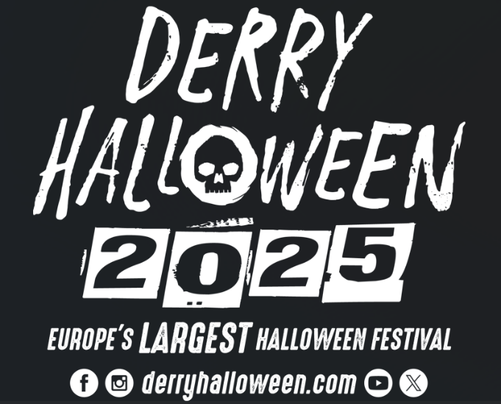
Application for City Centre Arts & Cultural Venues Subvention Funding

Introduction
Derry City and Strabane District Council (DCSDC) is inviting applications to support arts and cultural initiatives or programming that will interpret this year's festival theme.
We are particularly interested in encouraging family-friendly arts and cultural initiatives. To support this, the Council invites proposals from businesses, venues, and organisations to offer extended programming that will enhance the visitor experience.
The city offers a unique and dramatic stage, integral to the Council's ongoing initiatives to celebrate our rich business and cultural heritage. In line with this, Council is developing a vibrant programme of events for this year’s Derry Halloween, with dedicated funding available to support arts and cultural initiatives in and around the City Centre that will be part of this year's Halloween festivities.
From 28th – 31st October 2025, Derry Halloween will unfold over four nights, where the realms of the past and present will converge to present a breathtaking street celebration of everything eerie in the official home of Halloween.

Awakening the Walled City Trail
Dates: Tuesday 28th – Thursday 30th October
Times: 6pm –9pm
The trail will take place in and around the walled city creating a circuit that’s perfect for crowds, capable of handling large numbers of people and ensuring crowd control. It will offer a safe and leisurely way for visitors to explore themed locations and experiences at their own pace.
Halloween Day/ Night
Dates: Friday 31st October
Times: 12pm - 9pm
The Halloween Day / Night festivities will primarily centre around Guildhall Square, Waterloo Place, The Craft Village and The Quay.

Background
Celebrating its 39th anniversary this October, Derry Halloween has evolved from small and unassuming beginnings within the local community to become an internationally acclaimed event.
This home-grown festival promises visitors a unique and authentic experience, drawing inspiration from the Celtic roots of Halloween and the city's abundant artistic, cultural, and architectural heritage to harness the imagination and participation of the entire city and district.
The Council Festival and Events Team have been working on the best way to deliver Derry Halloween in a way that still complies with health and safety without compromising the wonder and magic that has come to be expected as standard for this international event.
Traditionally, the festival has created an enchanted world of illusion and wonder within the confines of the city walls and its surrounding streets for three consecutive nights, known as ‘Awakening the Walled City’.
Audience
We anticipate over 110,000 people in attendance during the Derry Halloween period.
The audience profile is mainly a family audience at this event. Proposals should take this into account.
Festival Theme
At the heart of ‘Awakening the Walled City’ lies a shared celebration of imagination, wit, wonder, and folklore, where people transform, tell the tallest of tales and the unbelievable seems believable for a few enchanted days and nights. Fundamental to this concept is the belief that each Halloween, this ancient walled city becomes the destination of choice for supernatural beings and spirits from the otherworld, as they awaken to roam the earth alongside the living before the dawn of a new year (traditionally, the Celtic New Year began on 1st November).
In recent years, a group of local artists created a series of urban legends linked with Celtic Halloween mythology, weaving narratives that resonate deeply with the city. These eerie characters, born from imagination, can be explored in the documents attached and also the following link --->https://www.youtube.com/watch?v=qEDOa4Ic9l4
Each year, we continue to develop these stories along with the broader rich history of the city within the walls, aiming to establish the City of Bones theme and characters synonymous with the festival’s identity in the future, under the overarching festival title ‘Awakening the Walled City’.
Council is always eager to seek out new stories and are not restricted to those already developed. Organisations should consider expanding and developing either these stories or other stories and folklore that have contributed to Derry Halloween’s success.
The city walls are filled with stories of life, death, and the afterlife. The footprint of the city has changed over 400 years; many buildings remain, but their stories have changed. If only the walls could talk, what would they say? What have they witnessed? What history has been lost? Derry truly is a city of bones that has long played witness to many Celtic traditions. As per previous year’s, the overall Halloween theme is "City of Bones." or any of the below themes relating to the event footprint:
- The Diamond – Disco at The Diamond - we envision a party like theme where creatures/ characters have burst through the veil, and they are here to party for one night only!
- Bishop’s Street – Bones of Bishops Street – we envision this street more eerie, haunting and dark. Some of the creatures from the other side are not happy & they will let it be known.
- London Street/ Pump Street – ‘Pump’kin Street – hello all things harvest, rustic and traditional. Trick or treat, bobbing for apples, turnips, pumpkins & disguises. What are our Celtic traditions?

Please note: Applications are NOT restricted to the above streets/themes. Therefore, any proposal that does not tie in with the above themes will still be considered and placed in other streets such as Artillery Street, Magazine Street, The Walls as a stage (Artillery St & Magazine St), Society Street & Butcher Street etc.

Applications
Derry City and Strabane District Council is inviting submissions from businesses, venues, and organizations within a ½ mile radius of the City Centre to offer arts and cultural programming aimed at enhancing the visitor experience.

The purpose of this application is to seek proposals that support arts and cultural initiatives interpreting this year’s overall Halloween theme, "City of Bones." or any of the themes relating to the event footprint above.

Please note: Applications are not restricted to the above streets/themes. Therefore, any proposal that does not tie in with the above themes will still be considered.

Examples of programming might include, but are not limited to entertainment, workshops, demonstrations, performances, installations, tours and trails, screenings, storytelling, music or drama, thematic decorations, and selfie stations.

Both individual and collaborative proposals are encouraged for submission as part of the Derry Halloween arts and cultural initiatives. Successful submissions will be promoted as part of this year’s Derry Halloween, running from the 28th - 31st of October 2025.

This initiative aims to reflect the diversity of arts, heritage, business offerings, and beautiful spaces within the city centre. Organizations can set a ticket price for their visitor experiences. While there are no restrictions on pricing structures, organizations are encouraged to ensure accessibility for all.

Businesses, venues, and organizations will be responsible for managing their own proposals.

Funding
Funding available for this creative programming will support one off activities:
- Up to a maximum of £500 for single activities
- Up to a maximum of £1,500 for multiple day / evening activities
- Up to a maximum of £750 for static installations
Funding will be based on Criteria and the number of applications that are received.

Information to be provided.
We are particularly keen to encourage family-friendly arts and cultural initiatives. To support this, the Council invites proposals from businesses, venues, and organizations to offer extended programming that will enhance the Derry Halloween event experience.

The Council aims to ensure that innovative, bespoke, and exciting arts and cultural programming complements the Council's programme and increases the event's appeal to local, national, and international visitors. Proposals that attract a broader cultural audience are encouraged.

Proposals should clearly include:
- Event description
- Location and duration of proposed activity
- Theme and artistic/creative excellence
- Experience
- Budget
- Marketing

Applicants should submit a creative proposal detailing the businesses, venues, or organizations' proposed animations, activities, entertainment, workshops, or performances. This should include an indication of any proposed fees for the activities, hours available, and age category targeted.
Suppliers should understand that the Council needs to accommodate a variety of proposals to meet the project's overall objectives and maximize the event's impact on the public. Consequently, the Council reserves the right to award contracts to multiple bids within each category, as budget permits.
Please note that the Council will retain all rights to any materials, imagery, or content developed for Derry Halloween as part of this process and reserves the right to reuse them for the promotion and development of future events.
All successful applicants must provide full marketing information on their event to enable the Council to promote it through their marketing channels. Additionally, all promotional material for the event must include the Council's logo and the Derry Halloween logo. The Council reserves the right to withhold funding from any event that does not provide marketing information details and does not include the appropriate logos.
Any queries on the event or your eligibility to apply for funding should be directed to
orlaith.meenan@derrystrabane.com

Application
Name of Organisation

Address of Organisation

Type of Organisation

Contact Name

Contact Email

Contact Telephone

Title of Project/Event

Location of Event

Dates & Times

Website / Facebook etc

Please complete the following section giving as much detail as possible about your planned project / event.

Events Description:
Please provide a detailed description of your proposal, including the proposed location and nature of the installation or activity. Identify your collaborators for developing and delivering the proposal and explain how this will enhance community participation and engage target audiences.

Include comprehensive details of the activities, covering who, what, where, why, and how, and emphasise the quality of your proposed event.
Although optional, providing images or sketches can enhance the visual impact of your proposal. (25 marks) (600 Words max)
Venue:
Please provide details of the venue / organisation location in proximity to the City Centre and the duration of the proposed activity.
(20 marks) (300 Words max)
Theme:
Please outline how the event aligns with the overall Derry Halloween program and the "Awakening the Walled City" theme. Highlight how your proposal will promote artistic and creative excellence while enhancing the experience for the target audience.
(20 marks) (300 Words max)
Experience:
Please outline your previous experience in delivering similar projects
(150 Words max)
Budget:
Please provide a detailed breakdown of costs, fees, production expenses, and a breakdown of performance fees, indicating where this funding will be allocated. You may utilise the following table format to assist you.

(20 marks) *All expenditure must be detailed
Expenditure  Details | Itemised  Costs | Total Costs | Amount Required Form DCSDC | Other  funders

Total DCSDC Arts Cultural Award Amount(s) you are applying for?
If the cost of the Event is more than you have applied for, have you identified the rest of the funding you need? | Yes No
If yes to the above, please indicate:
- Amount Secured
- Amount Pending

Marketing:
Please provide a detailed outline of the marketing plan for the event, including social media engagement/ expanding audience reach etc.

(5 marks) (100 words)
Health & Safety
Please outline how your organisation plans to manage and adhere to Health & Safety requirements (i.e. entertainment licence) while delivering the event.
(10 marks) (150 words)
Halloween Day
Please outline if you are willing to remain open on Halloween day and the required budget to include Halloween day into your proposal

Council reserves the right to select one or multiple proposals based on the available budget and the scores attained. Organisations can apply for various programming budget options but will only be granted one award.

If you have been unsuccessful in your application
If you are unsuccessful in this application process other options may still be available for you. Please mark accordingly based on your application being unsuccessful, we will do our best to ensure your application can take place.

- Please contact me to discuss an adjusted proposal on the trail if I am unsuccessful
- I am an artist/ group that requires a paid performance space/ venue. Please get in touch to assist in providing a way to make my/our application come to fruition.
- I am a venue that will pay for a performer/ artist installation etc. Please get in touch to assist us with programming content.

Application Authorisation:
Signature | Position in Organisation | Date

Please submit your proposal to orlaith.meenan@derrystrabane.com no later than noon on Thursday 8th May 2025.

Orlaith Meenan
Festival & Events Office
Derry City and Strabane District Council
Council Offices
98 Strand Road
Derry
BT48 7NN
orlaith.meenan@derrystrabane.com
We will be hosting a Halloween engagement event for artists, community groups, venues and businesses on Thursday 27th March at The Playhouse/ Artillery Street
Registration & Tea/ Coffee 4:30-5:00pm starting at 5pm.

During this event we will present an overview of the core elements/ structure for Derry Halloween 2025. If you would like to attend this event, please can you contact orlaith.meenan@derrystrabane.com to receive your official invitation.

