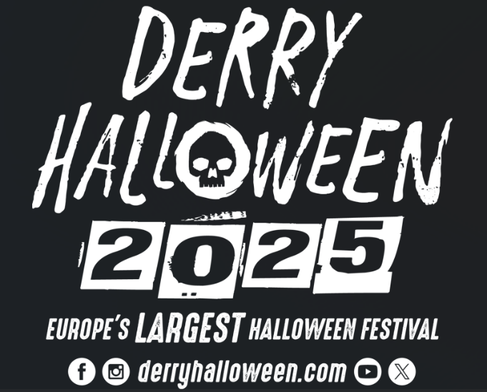

Derry Halloween 2025
Community Animation Call Out – Awakening the Walled City

Introduction
From 28th – 31st October 2025, Derry Halloween will unfold over four nights, where the realms of the past and present will converge into a breathtaking street celebration of everything eerie in the official home of Halloween.

Derry City and Strabane District Council (DCSDC) is seeking proposals for creative, interactive installations, displays, and performances as part of the Awakening the Walled City Trail (ATWC) at Derry Halloween 2025.

Proposals should envisage an interpretation of Derry Halloween and its festival themes. Both individual and collaborative submissions are welcomed.

Awakening the Walled City Trail
Dates: Tuesday 28th – Thursday 30th October
Times: 6pm –9pm
The trail will take place in and around the walled city creating a circuit that’s perfect for crowds, capable of handling large numbers of people and ensuring crowd control. It will offer a safe and leisurely way for visitors to explore themed locations and experiences at their own pace.

Halloween Day/ Night
Dates: Friday 31st October
Times: 12pm - 9pm
The Halloween Day / Night festivities will primarily centre around Guildhall Square, Waterloo Place, The Craft Village and The Quay. Council is also working with a number of city centre venues to establish a trail of animated performances/events during Halloween Day itself.

Background
Celebrating its 39th anniversary this October, Derry Halloween has evolved from small and unassuming beginnings within the local community to become an internationally acclaimed event.

This home-grown festival promises visitors a unique and authentic experience, drawing inspiration from the Celtic roots of Halloween and the city's abundant artistic, cultural, and architectural heritage to harness the imagination and participation of the entire city and district.

The Council Festival and Events Team have been working on the best way to deliver Derry Halloween in a way that still complies with health and safety without compromising the wonder and magic that has come to be expected as standard for this international event.

Traditionally, the festival has created an enchanted world of illusion and wonder within the confines of the city walls and its surrounding streets for three consecutive nights, known as ‘Awakening the Walled City’.

Locations for each successful proposal, within or around the Walled City, will be agreed upon in collaboration with Council as we aim to intertwine these with the larger pieces that we have planned.

Audience
We anticipate over 110,000 people in attendance during the Derry Halloween period.
The audience profile is mainly a family audience at this event. Proposals should take this into account.

Festival Theme

At the heart of ‘Awakening the Walled City’ lies a shared celebration of imagination, wit, wonder, and folklore, where people transform, tell the tallest of tales and the unbelievable seems believable for a few enchanted days and nights. Fundamental to this concept is the belief that each Halloween, this ancient walled city becomes the destination of choice for supernatural beings and spirits from the otherworld, as they awaken to roam the earth alongside the living before the dawn of a new year (traditionally, the Celtic New Year began on 1st November).

In recent years, a group of local artists created a series of urban legends linked with Celtic Halloween mythology, weaving narratives that resonate deeply with the city. These eerie characters, born from imagination, can be explored in the documents attached and also the following link --->https://www.youtube.com/watch?v=qEDOa4Ic9l4

Each year, we continue to develop these stories along with the broader rich history of the city within the walls, aiming to establish the City of Bones theme and characters synonymous with the festival’s identity in the future, under the overarching festival title ‘Awakening the Walled City’.

Council is always eager to seek out new stories and are not restricted to those already developed. Organisations should consider expanding and developing either these stories or other stories and folklore that have contributed to Derry Halloween’s success.

The city walls are filled with stories of life, death, and the afterlife. The footprint of the city has changed over 400 years; many buildings remain, but their stories have changed. If only the walls could talk, what would they say? What have they witnessed? What history has been lost?

Derry truly is a city of bones that has long played witness to many Celtic traditions. As per previous year’s, the overall Halloween theme is "City of Bones." or any of the below themes relating to the event footprint:

- The Diamond – Disco at The Diamond - we envision a party like theme where creatures/ characters have burst through the veil, and they are here to party for one night only!
- Bishop’s Street – Bones of Bishops Street – we envision this street more eerie, haunting and dark. Some of the creatures from the other side are not happy & they will let it be known.
- London Street/ Pump Street – ‘Pump’kin Street – hello all things harvest, rustic and traditional. Trick or treat, bobbing for apples, turnips, pumpkins & disguises. What are our Celtic traditions?

Please note: Applications are NOT restricted to the above streets/themes. Therefore, any proposal that does not tie in with the above themes will still be considered and placed in other streets such as Artillery Street, Magazine Street, The Walls as a stage (Artillery St & Magazine St), Society Street & Butcher Street etc.

Application / Categories
The purpose of this application is to provide the best experience for both locals and visitors by displaying our home-grown local talent that has made this festival what it is.

This procurement process is to identify providers for the animation outlined below.
This event aims to,

- Pop-Up Animation
£300 – x3 hours per night for 3nights (singular people)
Street Performers, Pop Up Musicians, Storytelling, Ghost storytelling (18+). Roaming Characters

£900 – x3 hours per night for 3nights (for groups under 10 people)
Street performers, Musical Theatre, Pop Up Choirs, Flash Mobs, Roaming Groups

- Animated Windows (£1000 – 2000 per window & within the themed streets only)
Animated empty windows brought to life through themed dressing and live animation. Please identify empty windows / locations in the proposal. Budget includes installation and take down for x 3 evenings. (Shipquay Street, The Diamond, Bishops Street, Pump Street Castle Street, London Street & Magazine Street Only)

- Mobile Street Performances- for groups over 10 people (up to £5,000)
Choreographed group performances, Musical Theatre performances, Flash Mobs. Budget includes performances for 3hours per night x3 evenings.
Please note that the maximum fee paid per proposal is anticipated to be no more than £3,000. This will be relevant to the number of performers, scale, specialist elements etc. In exceptional circumstances (dependent on proposal) a fee of £5,000 may be available.

** The above list is not exclusive, and we welcome bespoke performances. **

Duration of all Submissions
All submissions should be deliverable from 6pm-9pm on the 28th, 29th & 30th of October 2025. Where applicable please highlight set build/ installation time required in advance of 6pm.

Council will work with each successful applicant on timing of comfort breaks to ensure consistent delivery of a certain percentage of animation during the trail nights.

There is no limit to the number of submissions an individual/company can submit but a separate proposal is required for each. All proposals MUST indicate which category your submission is for.

Proposals will be assessed based on creativity, link to festival themes, cost and value for money.

Specification

Your submission should clearly:
- Outline proposal
- Identify who you will work with to develop and deliver your proposal and how this enhances community participation in the ATWC event.
- Identify how your proposal will promote artistic excellence and enhanced audience experience.
- Describe your piece – dimensions/ materials used/ how you will power etc.
- Provide sketches/ images of your piece where available.
- Identify location (indicate all possible sites and preferred option)
- Indicate all necessary infrastructure needed to support the safe set up, running and take down of the installation (i.e., barrier requirements, stewarding, permissions etc)
- Installation’s themes should relate to Halloween.
- Be Self-Sufficient and Standalone
- Indicate the use Portable Power Supply where needed.
- Be Weatherproof
- Comply with H&S Requirements
- Artist/Organization are responsible for installation and take down.

Council welcomes submissions from all the above categories but does reserve the right to choose some or all the proposed submissions for the event. Please note, that there is a limited number of performances that can be accommodated out of the budget set aside under local animation. Assessments will be made within each category, with the aim of achieving a diverse mix of proposals across both smaller value proposals and larger value applicants.

Please note that insurances, activity-based risk assessments and event management plans will all be required prior to contract if successful. Council can provide templates and advice to assist with this.

Please also note that successful individual/ organisations must commit to press/PR activity and interviews as and when requested.

Suppliers will appreciate that Council will need to accommodate a variety of proposals to meet the overall objectives of the project in order maximise the impact to the public of this event. Therefore, to do this council reserves the right to award contracts to several bids within each category up to the maximum budgets permitted.

Applicants must not make assumptions that DCSDC has prior knowledge of their organisation or their service provision. Applicants will only be evaluated on the information provided in their application.

Please note that Council will retain all the rights for any materials, imagery or content developed for Derry Halloween as part of this process and reserve the right to reuse for the promotion and development of future events.

If you have been unsuccessful in your application
If you are unsuccessful in this application process other options may still be available for you. Please mark accordingly based on your application being unsuccessful, we will do our best to ensure your application can take place.

- Please contact me to discuss an adjusted proposal on the trail if I am unsuccessful
- I am an artist/ group that requires a paid performance space/ venue. Please get in touch to assist in providing a way to make my/our application come to fruition.
- I am a venue that will pay for performer/ artist installation etc. Please get in touch to assist us with programming content.

Evaluation Criteria

 | Weighting
Q1. Proposal  Organisations/individuals should provide a detailed description of the event/idea/performance they are proposing including where applicable.  Creativity of proposal, number of performers/acts, alignment with the festival theme ‘City of Bones’, street themes & local narratives, number of performers/acts, performance duration, repetition of performance and how it will enhance the quality and appeal of Awakening the Walled City Trail. Outline any partnership links with other groups / organisations.  Please also indicate if this is a new piece or has been showcased before.  (600 Words max) | 60%
Q2. Location & Infrastructure  Please identify the preferred location and outline all necessary infrastructure needed to support the safe set up, running and takedown of the installation (i.e., barrier requirements, stewarding, permissions, etc.)  Time frames for set up and take down to be included. | 30%
Q3. Costs  Costs should be exclusive of VAT – including hourly/daily/multiple day rates for hire and performers. Costs should be inclusive of all management, transport, and delivery. You might also wish to give costs for a variety of delivery options.  Please clearly cost individual elements within each category | 10%
Q.4 Halloween Day
Please identify how your event/idea/performance can take place on Halloween day in Guildhall Square/ Waterloo Place. Please include additionality in terms of costs/ times if this were to go ahead on Halloween day.

Resources
We appreciate that your proposal(s) may involve several artists and companies working together. The Festivals and Events Team will work closely with the successful organisations once they are appointed with regular communications specific to each installation, taking place from May 2025 onwards.

Several resources will be provided by Council including.
- Production Meetings with Festival & Events Team
- Site Security
- Barriers
- Site Services
- Radios
- Event Control Management
- Traffic Management

We will be hosting a Halloween engagement event for artists, community groups, venues and businesses on Thursday 27th March at The Playhouse/ Artillery Street
Registration & Tea/ Coffee 4:30-5:00pm starting at 5pm.

During this event we will present an overview of the core elements/ structure for Derry Halloween 2025. If you would like to attend this event, please can you contact orlaith.meenan@derrystrabane.com to receive your official invitation.

Please submit your proposal to orlaith.meenan@derrystrabane.com no later than noon on Thursday 8th May 2025.

